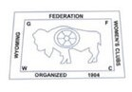
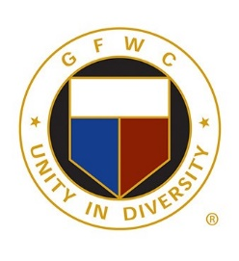
GFWC Wyoming
2022 Creativity Awards

Juniors’ Special Program: Advocates for Children
GFWC Woman’s Club of Rock Spring – Stuff the Bus

Arts and Culture Community Service Program
GFWC Yoder Woman’s Club – Art in the High School

Civic Engagement and Outreach Community Service Program
GFWC Women’s Civic League of Cheyenne – Tea Party at Assisted Living

Education and Libraries Community Service Program
GFWC Laramie Woman’s Club – Visiting Author

Environment Community Service Program
GFWC Women’s Civic League of Cheyenne – Sock Collection

Health and Wellness Community Service Program
GFWC Woman’s Club of Rock Springs – Walking Trails

Communications and Public Relations Advancement Plan
GFWC Woman’s Club of Rock Springs – 100th Anniversary Celebration

Fundraising and Development Advancement Plan
GFWC Laramie Woman’s Club – Christmas at the Mansion

Leadership Advancement Plan
GFWC Meadowlarks – Veterans’ Rock Support

Membership Advancement Plan
GFWC Yoder Woman’s Club – Open Coffee Times

Women’s History and Resource Center
GFWC Laramie Woman’s Club – Archived Music & Documents

