KALEIDOSCOPE

September 2022

President’s Message
DENISE LATHROP

Welcome back to another exciting new Club year. The Fall is always an exciting and busy time. This is the time we begin bringing in our money for our grants, one of our most important events of our club’s life. I would also like to extend a warm welcome to our newer members and let you know how much we appreciate your membership. If you have any questions, please email me or anyone you know in the club for answers. We want you to become at ease here and enjoy our club activities. Again welcome all to our new year.

Corresponding Secretary

KRISTIE ACKERSON

August Correspondence:

Sympathy Cards sent to the families of Wilma Lathrop and Van Mellblom.
Sympathy Card sent to Sandy Pedersen (husband) and Earleen Weaver (brother-in-law).

Second Vice-President
LUCY PAULEY
September luncheon will be at the Cheyenne Country Club beginning at 11:30 with social time. We will again be offering the Zoom option for our meeting. Linda Stowers will be sending out an email with the invite.
Lucy Pauley
(307) 221-2056
YEARBOOK CHANGES
A special thanks to Pat Stenback for her work on the Yearbook. It will be available at the Luncheon. If you are unable to pick one up, please contact Pat to make arrangements to get one. The insert is just the first part of the book. We made no changes to the By-laws so just keep them in your book.

Changes to the 2022-23 Yearbook

Luce Anspauch, Lifetime Member
1540 Adams
637-4601

Resignations:
Shelly Herr
Diane Nyffler

ENVIRONMENT
ENVIRONMENT COMMUNITY SERVICE PROGRAM
Phyllis Salzburg, Chairman

COLLECTIONS! Bring to September meeting or call Phyllis, 421-1516, for pick up
Used athletic shoes, any brand or condition, for Nike Grind project. Nike gives lightly used pairs to those in need. Others are ground up for playground material.
New and Used Bras for Free the Girls. Bras are given to survivors of human trafficking so they can start their own small business.
Socks – Any style, color, brand, style, material, condition. Smartwool recycles clean socks into dog beds.

Donations will be taken to GFWC-W State Conference October 8.

Christmas lights – continuing to collect unwanted lights through the fall.
*****************************
CHEYENNE GREENWAY: FALL CLEAN UP OF OUR GREENWAY LOCATION –
Saturday September 24, 2022, 9:30 a.m. Cowboys football is away at BYU. Bags and light gloves will be provided. We did such a good job in the spring this cleanup shouldn’t take long! Bring your own gloves if you prefer heavier ones and trash pick up stick if you have one.

Location (same as last spring) is in Sun Valley, Henderson Dr. trailhead to Baldwin Dr. trailhead, approximately .61 miles (1.22 miles round trip). Directions from the north: Take Ridge Road south across Nationway, turn right on Belaire Ave., turn left on Henderson Dr., go to end of road where trailhead begins.

Our Greenway Wayfinding sign at the corner of Storey and Converse should be installed the end of September or early October.
***************************
GFWC Community Connections Initiatives
The GFWC 2022-2024 administration has initiatives in the Community Service Program areas to make a visual, physical or emotional impact at the grassroots level. The Environment initiative, Sparkling Seeds, Brilliant Butterflies, Glamorous Garden Gloves promotes community gardens. Call Phyllis for more information or with ideas – let’s talk about finding a spot!

MILITARY
Join a FUN group of ladies who support military members and their families who live in our community!

We will have our first meeting of the year this Wednesday at 10:45 am in the bar area of the Country Club.

The Veteran's Stand Down for Homelessness will be held on Tuesday, October 25th from 10 am to 2 pm at Forum 619 (619 S Greeley Hwy.). We will be collecting warm winter clothing items such as socks, hats, gloves, sweatshirts, sweatpants, coats, etc. to give to the veterans and their families who are in need. Please bring items that you would like to donate to our October meeting. If you would like to assist with handing out the items at the event, please contact Carolyn.

A reason to celebrate: September 17 is the Air Force's 75th Birthday!

HEALTH AND WELLNESS
WELCOME BACK TO ALL GFWC-WCLC CLUBWOMEN:
The WCLC Health and Wellness committee is so excited to be back to work to help those in need in our community as well as offering ideas to help keep our membership and those around us healthier and “Well”.
We encourage all members to pick one or more committees to participate on this year and hope you will support the work of these hard- working chairwomen and the wonderful projects they bring to our membership.
Please contact these Committee Chairwomen for more information as to how you can get involved:
Elise Johnson- Senior Services
Judy Lissman- Youth and Family Services
Heather Dodson- Special Needs
Wendy Owen- Women’s Issues
September Focus:
OBSERVING AWARENESS MONTHS:
Observing awareness months is an opportunity to reflect on the resilience of survivors, perseverance of advocates, and the roles our community can take to support survivors and the efforts of community-based programs. Each month we will provide an overview and the intersections of sexual violence, domestic violence, and human trafficking. We will also highlight the voices of the many courageous survivors who have made tremendous contributions while overcoming trauma. Additionally, we will provide resources, prevalent data, and opportunities to actively participate in generating awareness in your community. It is also a moment to acknowledge sexual assault, domestic violence, and human trafficking survivors and advocates whose voices and leadership have created change and who have dedicated their lives to eradicating gender-based violence.
Gender-based violence refers to multiple forms of harm directed toward a person based on their gender. It is most referenced internationally as a human rights violation, an abuse of power, and rooted in gender inequity. You will also hear the term Violence Against Women, based on the federal Violence Against Women Act. Both terms are also used as a catch-all for sexual assault and domestic violence. These terms are defined in federal statute; however, we will dive deeper into the definitions and public discourse over the next year.
Each of these forms of violence thrive in secrecy and shame. It is important to remember these forms of violence and know that prevention, education, and awareness are fundamental to creating a society free from violence where people can thrive.
Below is a list of the awareness months to mark on your calendar:
- January: Human Trafficking
- February: Teen Dating Violence
- April: Sexual Assault Awareness and Prevention Month
- October: Domestic Violence Awareness Month
SPECIAL NEEDS
GFWC International awarded $2500 to our club for the Community Improvement Program we submitted. This was awarded on the 3 Special Needs Program. The partnership with Walmart for gift cards at Christmas, the Valentine Program and the Greenhouse Project at South High with the special needs students. We are again very proud of our club and their projects helping the community. See the pictures of the completed Greenhouse.

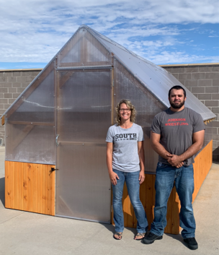
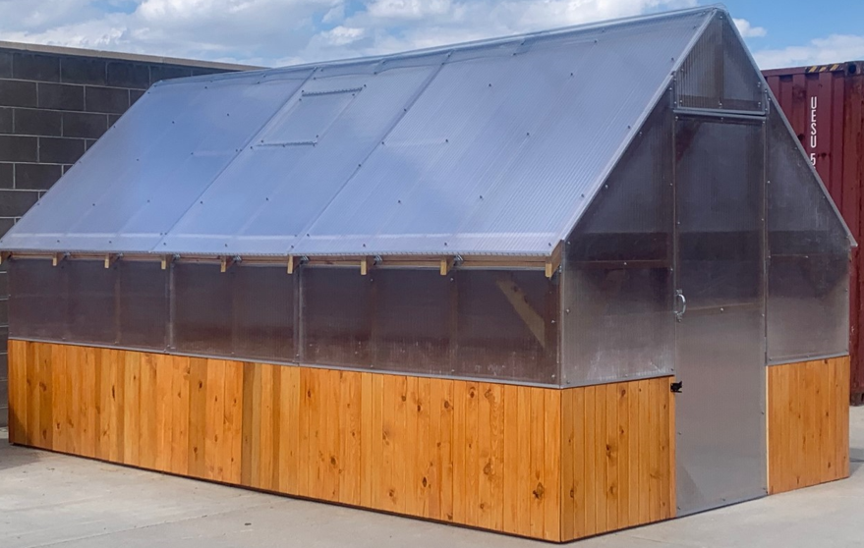

ESO BOOK CLUB
BOOKS FOR THE YEAR 2021-22
The book for September is Eleanor. The group will be meeting on Monday September 26, 9:00 AM at The Boardroom, 1788 Carey. Plan to join even if you haven’t completed reading the book.

CHRISTMAS HOUSE
Fall will officially arrive on September 22, and that means Christmas House is just a couple of BER months away – OctoBER and NovemBER. The countdown really begins!

We are looking for sewers for easy projects and members to make candles (the crackle kind made with wax and molds). Also needed are shutters, spindles, and old chain link.

Room Chairs, please bring workshop sign-up sheets to the September meeting. Pam Crochet will collect them. Also, please place your requests regarding workshop invites and/or information, and needed project items, etc. in the Christmas House E-Gram and Kaleidoscope to reduce the number of emails going out. You may send your requests to Joyce Bailey and Linda Stowers respectively.

Members, please check the Christmas House requirements listed in the E-Gram to make sure you are on track.

The Wreath Competition is scheduled for Sunday, October 9 at the Cheyenne Depot from 2 pm – 4 pm. Further details forthcoming at the September meeting and in the E-Gram. An update on the Flippin’ Fun Competition that took place on September 11 will also be given at the September meeting.
Thanks for what you do!
Team Christmas House 2022
Deb, Deb, Pam & Kathy

SOCIAL GROUPS
GOURMET NEWS
Interested in having some cooking fun? How about expanding your cooking/baking skills? Want to try some new recipes? We will be happy to have you join our gourmet groups.
Be sure to sign up at the meeting on Wednesday, September 14 to get on the list. We will be drawing for groups at our organizational meeting at Pam Crochet’s home at 200 Talon Court on Wednesday, September 28 at 10:00 am. We will serve coffee/tea, rolls and discuss plans for the coming year of gourmet. Please let me know if you are unable to come and we will make sure to include your name in the draw for groups. We presently have four leaders and depending on the number of interested members, could make 4 or more groups. Let me know if you are interested in being a group leader.
After the draw we will break into our groups and make plans. We typically meet the fourth Wednesday of the months of October, January, February and March. We can decide if we want to add April. Cost will be discussed due to the higher prices of groceries. Come so we can get your ideas, input, and some new suggestions.
Contact Judy Lissman to register or with questions regarding gourmet.
307-575-1102.
jlissman1@gmail.com
See you Wednesday for registration.

NEEDS
BRING YOU PEANUT BUTTER AND JELLY TO THE MEETING!!
This Photo by Unknown Author is licensed under CC BY-SA-NC

OTHER INFORMATION
MEALS ON WHEELS ROUTE – Always in need of drivers, many organizations and businesses have routes where their employees/members deliver a designated route once a week. There are currently routes available on Monday and Friday.

If you would like to help or would like more information, contact Phyllis Salzburg. Let her know which day would work for you. If enough people sign up, members would only have to deliver once a month or possibly even once every two months. Meal delivery, depending on size of routes, usually takes no more than 1 to 2 hours, start to finish.

SOCIAL MEDIA

Follow Us on Facebook and Instagram

Search for us by Name:

GFWC Women's Civic League of Cheyenne

Please keep the community posted on what we are doing with Civic League. Help tell a story by emailing or texting Linda Stowers photos! Free advertising and a greater reach than TV or Newspaper!

GFWC Women’s Civic  League of Cheyenne  Denise Lathrop, President  Claudia Wilen, First Vice-President  Lucy Pauley, Second Vice-President  Meredith Dexter, Recording Secretary  Kristie Ackerson, Corresponding Secretary  Linda Stowers, Treasurer |  | Kaleidoscope  Published Monthly  September thru May  Linda Stowers, Editor  Lpstowers54@gmail.com

