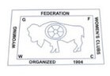
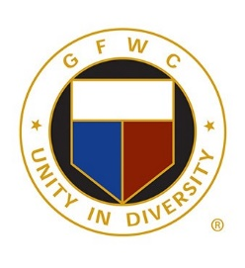
GFWC Wyoming 2021 Awards

Jennie Award
Pam Crochet from GFWC Women’s Civic League of Cheyenne

Community Impact Program
GFWC Women’s Civic League of Cheyenne – Assisting People with Disabilities
GFWC Meadowlarks – Feeding the Hungry

Signature Program: Domestic Violence and Sexual Assault Awareness and Prevention
GFWC Laramie Woman’s Club – Comfort Bags

Juniors’ Special Program: Advocates for Children
GFWC Laramie Woman’s Club – WIC Quilts and Pillows

Arts and Culture Community Service Program
GFWC Yoder Woman’s Club – Dollar Bill Exploration

Civic Engagement and Outreach Community Service Program
GFWC Laramie Woman’s Club – Adopt an Elder

Education and Libraries Community Service Program
GFWC Yoder Woman’s Club – Walking Book Project

Environment Community Service Program
GFWC Laramie Woman’s Club – Bra Collection

Health and Wellness Community Service Program
GFWC Laramie Woman’s Club – Sewing & Such

Communications and Public Relations Advancement Plan
GFWC Leading Ladies – Club Charter

Fundraising and Development Advancement Plan
GFWC Yoder Woman’s Club – Pheasant Hunters’ Dinner

Leadership Advancement Plan
GFWC XJWC of Cheyenne – CIP Selection Process

Legislation and Public Policy Advancement Plan
GFWC Yoder Woman’s Club – Pandemic Discussion

Membership Advancement Plan
GFWC Woman’s Club of Rock Springs – Advertising for Members

Women’s History and Resource Center
GFWC Yoder Woman’s Club – 100th Anniversary Celebration

