Woman’s Club of Rock Springs Newsletter
This Photo by Unknown Author is licensed under CC BY-SA
September 2020
P O Box 314
Rock Springs, WY 82902

Upcoming Meetings
Meetings Date/Time
Board September 3, /10:30 333 Broadway upstairs meeting room
Literature September 8, /1:00 333 Broadway upstairs meeting room
Busy Hands September 22, /1:00 333 Broadway upstairs meeting room
Remember there are no hostesses for these meetings. If you need a beverage or snack please bring your own. There is still a coffee pot available if you would like to make some.
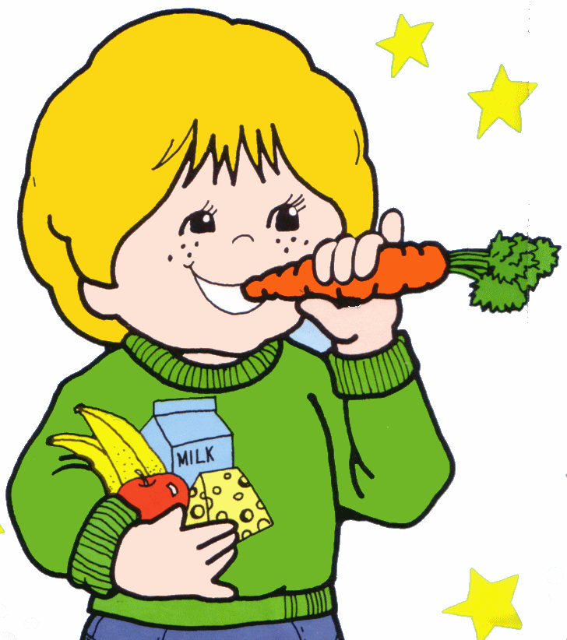
This Photo by Unknown Author is licensed under CC BY-SA-NC
General Meeting:
The general meeting will be held September 15 at 11:30 in Arthur Park, 3801 College Drive. Please bring your own lunch and beverage. So happy to be getting back together! Hope you can attend!
This Photo by Unknown Author is licensed under CC BY-SA-NC

Club Collecting:
- Cindy Wakefield is collecting purses, personal hygiene items for women all for the VA hospital mental health department. (body lotions, body wash/face wash, deodorant, feminine cleaner, tampons/pads, hair brush, comb, hair products, hair ties, large tote or purse.) no more shampoo, conditioner or soap for right now.
- Leslie Jo Gatti collects pop tops from aluminum cans or Ronald McDonald House and aluminum cans for the Humane Society.
- We are also collecting dimes for the State March of Dimes Project the next two years.
- Cindy Moore takes the following items to the Child Developmental Center: Greeting card fronts with no writing on the back, Empty Printer cartridges, children and adult books and unused envelopes.
- April Dittman is collecting shampoo, conditioner, deodorant, toothpaste, soap bars toothbrushes, towels, washcloths, Lotion, socks, underwear and bras for the youth home. Call April at 371-9909 for more details. Bring items to board or general meetings to give to April.
- Jackie Allison will be collecting blankets, underwear and books for veterans. Please bring to a general meeting to give her.

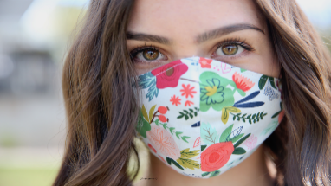
This Photo by Unknown Author is licensed under CC BY-NC-ND
Please keep track of hours and cost of face masks you have made and donated and let Edna know at the end of the year. Also, time and cost of other projects you are doing including making and sending cards to the elderly in nursing homes. Please continue making masks as there is still a need for them.
Club Spending:
- The board voted to give $300 each to the 5 applicants for our WWCC books grant. The applicants include Carol Ann Larson, Michaelee Wisniewski, Anthony Mitchell, Elizabeth Litchfield and Abby Bettolo.
This Photo by Unknown Author is licensed under CC BY-ND
- The board reviewed the list of places to donate from last Spring and will present the revised list at the September general meeting for approval of the club.
The 2020-2021 yearbook is now available. Please contact Marcia Volner to arrange to get your copy. They may be emailed if you prefer that to a paper copy.
This Photo by Unknown Author is licensed under CC BY-SA
Karla Roich has a new email – kroich@q.com
Please use her 307-350-5707 phone number only.
State Board Information
For those of you holding state board positions there will be a State Board meeting on August 29th at 9:30 AM. Watch your email for instructions on joining this meeting.

GFCW WYOMING RECOGINIZES THE
100th Anniversary of the 19th Amendment with a Viral Tea
Equali “TEA”
Celebration
August 26
2020
Have a cup of tea. Take a Picture!
Send the picture to either of the following two ladies.
Starla Sexton
Nancy Kaufman
npkauf@comcast.net
starlasexton@gmail.com
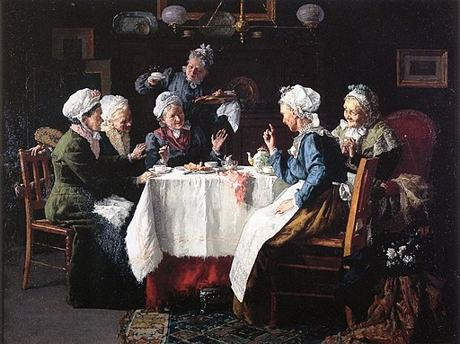

Find Out More:
WCRS Website www.gfwcrocksprings.org
WCRS Facebook Page Woman’s Club Of Rock Springs GFWCWyoming
GFWC State Website www.gfwcwyoming.org/
GFWC State Facebook www.facebook.com/WomansClubWY
International Website www.GFWC.org
All information for the newsletter is to be sent to mvwycoff@gmail.com

